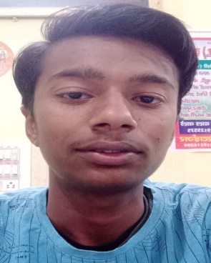
Resume
Mr. AMOGH GUPTA
Address:
MOHALLA DARJIYAN NEAR HATHI WALI GALI
CHANDAUSI DISTRICT SAMBHAL (UP) INDIA
Contact No:-7579480325
Email Id:- amoghgupta92@gmail.com
Career Objective
Self-motivated and hardworking fresher seeking for an opportunity to work in a challenging environment to prove my skills and utilize my knowledge & intelligence in the growth of the organization.
Academic Qualification
Exam Name | Board/University | Passing year | Percentage of Marks | Division
High School | UP BOARD | 2020 | 69 | FIRST
Professional Qualification
Exam Name | Board/University | Passing year | Percentage of Marks | Division
DIPLOMA IN ELECTRICAL ENGINEERING | RADHA GOVIND POLYTECNIC COLLEGE GOPALPUR CHANDAUSI | 2023 | 69.68 | FIRST
B.TECH IN COMPUTER SCIENCE | IFTM UNIVERSITY MORADABAD | 2024 | FOUR SEMESTER | STUDY
WORK EXPERIENCE
- 04/08/2022 TO 02/09/2022 EXPERIENCE IN UPPCL CHANDAUSI
PERSONAL INFORMATION
Date of Birth :- 2006-01-09
Father’s Name :- Mr. GOVINDRAM GUPTA
Mother’s Name :- Mrs. AMITA GUPTA
Nationality :- INDIAN
Gender :- MALE
Marital Status :- UNMARRIED
Language :- ENGLISH AND HINDI
Hobbies :- PLAYING CRICKET & BADMINTON
AND READ NEWS PAPER
DECIARATION:-
I hereby declare that all the statement made in this resume are true, complete and correct to the Knowledge.
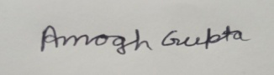
DATE:- 06/04/2024
PLACE:- CHANDAUSI DISTT. SAMBHAL (AMOGH GUPTA)

